## YEAR 11 PHYSICS SEMESTER 1

**PRACTICE EXAM C SOLUTIONS**

**Time allowed for this paper**:

Reading time before commencing work 10 minutes

Working time for paper 3 hours

**Materials required/recommended for this paper**

***To be provides by the supervisor***

This Question/Answer Booklet

Formulae and Data Booklet

***To be provided by the candidate***

Standard items: pens, pencils (including coloured), sharpener, correction fluid, eraser, ruler, highlighters.

Special items : up to three non-programmable calculators approved for use in the WACE examinations, drawing templates, drawing compass and a protractor.

**STRUCTURE OF THIS PAPER**

|  |  |  |  |  |  |  |
| --- | --- | --- | --- | --- | --- | --- |
| Section | No. of  Questions | No. of questions  to be attempted | Suggested working time  (minutes) | | Marks available | Percentage of  exam |
| 1: Short Response | 13 | ALL | 50 | | 51 | 34% |
| 2: Problem Solving | 7 | ALL | 85 | | 87 | 58% |
| 3: Comprehension | 1 | ALL | 15 | | 12 | 8% |
| Total | **150** | **100** |

**INSTRUCTIONS TO CANDIDATES**

Write your answers in the spaces provided beneath each question. The value of each question (out of 180) is shown following each question.

The enclosed Physics: Formulae and Constants Sheet may be removed from the booklet and used as required.

Calculators satisfying conditions set by the School Curriculum and Standards Authority may be used to evaluate numerical answers. The calculator **cannot** be a “**graphics”** calculator.

Answers to questions involving calculations should be evaluated and given in decimal form. Final answers should be given up to three significant figures and include appropriate units where appropriate. Despite an incorrect final result, credit may be obtained for method and working providing these are clearly and legibly set out.

Questions containing specific instructions to **show working** should be answered with a complete, logical, clear sequence of reasoning showing how the final answer was arrived at; correct answers which do not show working will not be awarded full marks.

Questions containing the instruction "**ESTIMATE**" may give insufficient numerical data for their solution. Show your working or reasoning clearly. Give final answers to a maximum of two significant figures and include appropriate units where applicable.

**Section One: Short Response 34% (51 marks)**

This section has 13 questions. Answer **all** questions. Answer the questions in the spaces provided.

Suggested working time: 50 minutes.

**Question 1 (4 marks)**

1. Draw a **labelled** diagram of a Helium atom, (not to scale). (2 marks)

* Clearly shows 2 protons and 2 neutrons in the nucleus (labelled) (1)
* Clearly shows two electrons orbiting/outside the nucleus (labelled) (1)

*[0 marks if not labelled]*

Electron

Neutron

Proton

1. In the nucleus of an atom many positively charged protons are packed closely together. Explain why the protons in the nucleus don’t fly apart due to electrostatic repulsion. (3 marks)

* The strong nuclear force acts between the protons and neutrons (1)
* When protons are close together (like in a nucleus) the strong nuclear force is stronger than the electrostatic repulsion between the protons (1)

**Question 2 (4 marks)**

Dogs don’t sweat like humans do, after exercising they pant to cool down. When dogs pant they stick out their wet tongue and blow air over it. Explain how the action of panting helps the dog cool down.

* Air passing over the tongue helps more saliva/water evaporate (1)
* Saliva/water requires heat (latent heat of vaporisation) to evaporate (turn from liquid to gas) (1)
* By removing heat from dog panting helps keep the dog cool (1)

**Question 3 (7 marks)**

1. Calculate which light bulb draws the most current. (2 mark)

(1)

(1)

The 80.0 W light bulb draws the most current.

1. The light bulbs are then placed in a series circuit. Calculate the current through each light bulb.

(5 marks)

(1)

(1)

(1)

(1)

Both will have the same current, 0.142 A. (1)

**Question 4 (3 marks)**

A doctor of mass 75.0 kg is taking images of a patient using a beta radiation source. If the radioisotope delivers 8.10 × 10-2 J of energy, calculate the equivalent dose the doctor receives.

(1)

(1.5) (1 = unit)

**Question 5 (4 marks)**

A 3.85 V battery is used to power a smart phone. The smart phone draws a current of 21.1 mA when watching videos. Calculate how much electrical potential energy is consumed while watching a 5.00 minute video clip.

(1)

(1)

(1)

(1)

**Question 6 (5 marks)**

Computers get very hot after being used for a long time, so they often contain fans which move air through the computer case. The fan draws air in through the front of the computer case and blows it out through the back.

1. Describe how moving air through the case keeps the computer electronics cool. (3 marks)

* The computer transfers heat energy to the air around it through conduction (1)

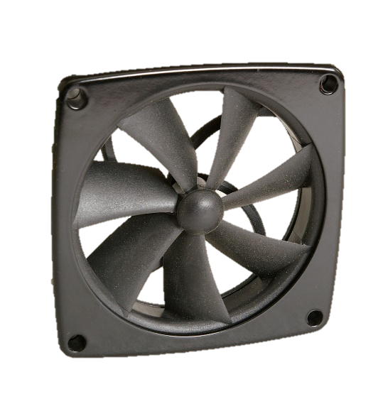

* As the air keeps being replaced the computer can’t reach thermal equilibrium with the air (1)
* So, they computer keeps losing heat energy, thus remaining cool (1)

1. Some computers are water-cooled. They pump cold water through pipes positioned alongside components to keep the computer cool. Which system (air cooling or water cooling) would be the most effective at keeping the computer cool? Explain the reasoning behind your answer. (2 marks)

* Water cooling (1)
* Water has a high specific heat capacity, can absorb a lot of heat energy from the computer before increasing in temperature (more than air) (1)

**Question 7 (4 marks)**

Complete the following nuclear decay equations:

1. (1 mark)
2. (OR ) (1 mark)
3. (OR ) (1 mark)
4. (1 mark)

**Question 8 (4 marks)**

The cups shown below are used to hold hot drinks, such as tea or coffee.

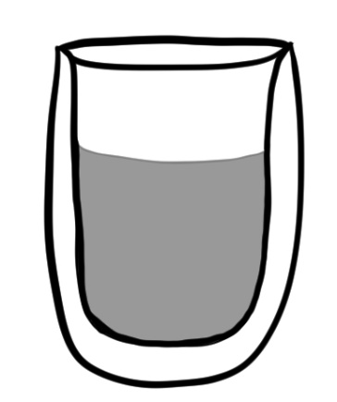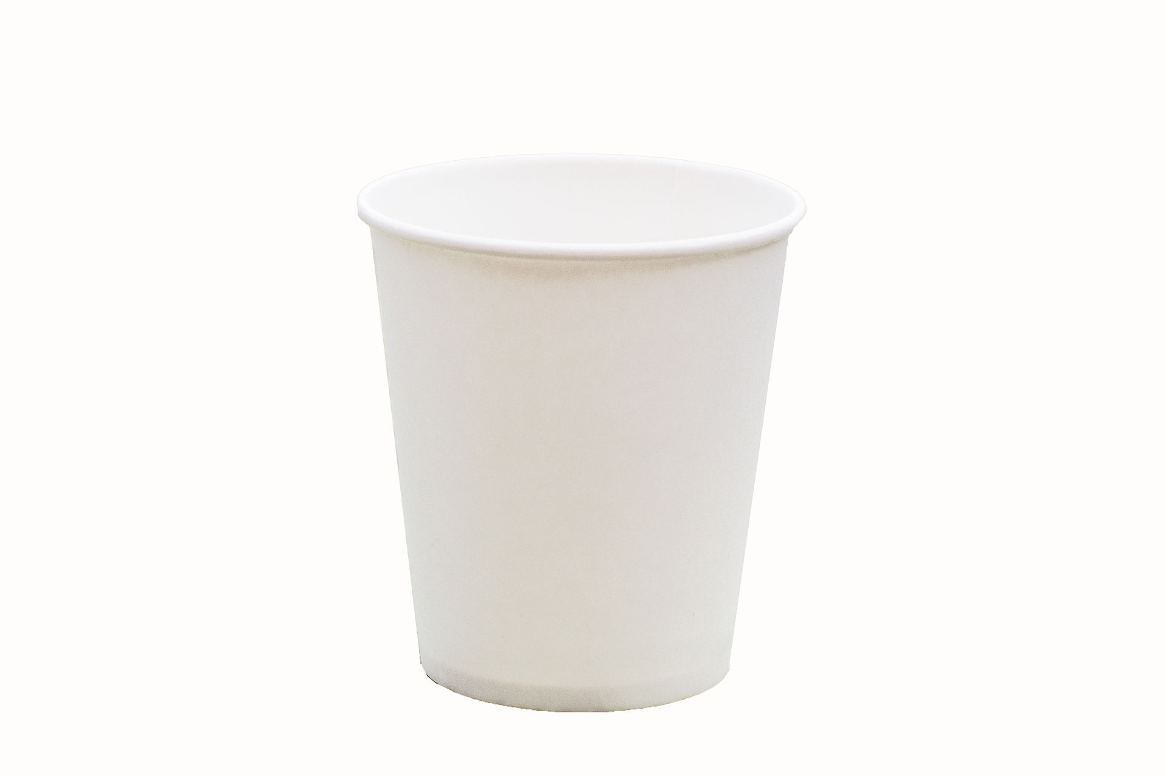

Glass

Layer of air

*Paper cup*

*Glass double-wall cup*

1. Which cup is better at preventing your hand from getting burnt? (1 mark)

* The glass, double-wall cup (1)

1. Explain why your chosen cup from part a) is more effective at preventing burns. (3 marks)

* The double-wall cup has a big air gap, air is a good insulator (1)
* Insulators don’t conduct heat very well (1)
* Less heat conducted to outside of cup and to your hand (1)

**Question 9 (3 marks)**

Draw a **labelled** circuit diagram of a parallel circuit containing a battery, two light bulbs and a switch. Arrange the components so that when the switch is closed both lights are on, but when the switch is open only one light is on.

* All components included and drawn with correct symbols (1)
* Components are labelled correctly (1)
* Circuit drawn as below (so when switch is closed both lights are on) (1)

Battery

Light bulb

Switch

**Question 10 (4 marks)**

An electric kettle with a rating of 300.0 W takes 2.50 mins to heat water from 25.0 °C to 70.0 °C. Calculate how much water was in the kettle. (Assume the transfer of energy is 100% efficient).

(1)

(1)

(1)

(1)

**Question 11 (3 marks)**

The ratio of neutrons (N) to protons (Z) can be used to calculate the stability of a nucleus.

For light elements with an atomic number less than 20, stable isotopes should have a N:Z ratio of 1:1 .

1. Find the N:Z ratio for the isotope and determine if it is a stable isotope. (2 marks)

= (0.5 mark for 4:8) (1 mark for 1:2)

Ratio is not 1:1 therefore is **not** a stable isotope (1)

1. Describe what happens to an isotope if it is unstable. (1 mark)

* Unstable isotope will spontaneously decay and emit radiation (1)

**Question 12 (3 marks)**

There are atoms in a sample of a radioactive element. If the element has a half-life of 10.0 minutes, calculate how many atoms of this element remain after 1.00 hour.

(1)

(1)

(1)

**Question 13 (4 marks)**

A football coach has a large container holding 50 L of sports drink for his team. The sports drink starts at 35 °C and needs to be cooled down to 0 °C before half time.

Calculate how much ice (initially at -10 °C) the coach needs to add to the sports drink in order to cool it down to 0 °C. (Assume sports drink has the same properties as water and that all the ice melts).

(1)

(1)

(2)

**END OF SECTION ONE**

**Section Two: Problem-solving 58% (87 marks)**

This section contains 7 questions. Answer **all** questions. Answer the questions in the spaces provided.

Suggested working time 85 minutes.

**Question 14 (12 marks)**

Sous vide is a way of cooking food at a low temperature over a long period of time. A sous vide machine is made of a container of water with a submerged heating element (see diagram below). An electrical current passes through the heating element, warming it up which then warms the water to a constant temperature. Food (e.g. steak) is placed in sealed bags and cooks in the warm water.

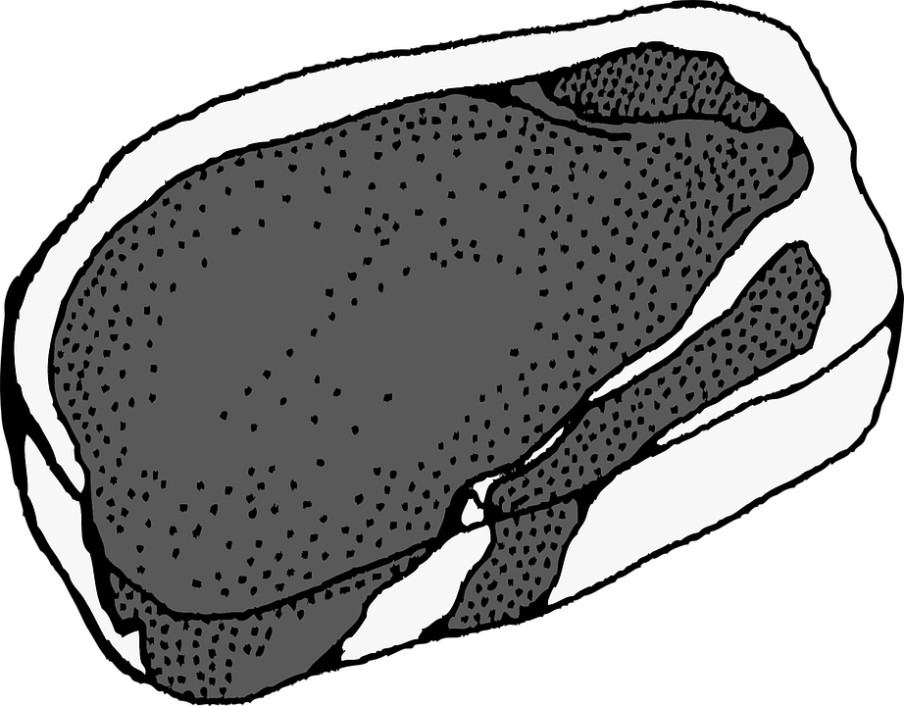

Water

Vacuum sealed bag

Steak

Heating element

Figure 1: Sous vide machine

1. A chef places 6.20 L of 28.0 °C water into a sous vide machine. The machine is rated at 2.10 kW. Calculate how long it takes the sous vide machine to heat the water up to 56.5 °C. (4 marks)

(1)

(1)

(1)

(1)

1. It actually took the sous vide machine 8.30 minutes to heat up the water from part a). Calculate the efficiency of the sous vide machine. (3 marks)

**Alternatively:**

(1)

(1)

(1)

(1)

(1)

(1)

1. A 300 g steak and 250 g of carrots were taken out of the fridge at 5.00 °C. The food was added to the sous vide machine when the water was 56.5 °C. However, the sous vide machine was accidentally turned off as soon as the food was added (so no extra heat was added to the water). Calculate the final temperature of the steak and carrots. Assume no energy is lost. (5 marks)

|  |  |
| --- | --- |
| **Food** | **Specific Heat Capacity (J K-1 kg-1)** |
| Steak |  |
| Carrot |  |

(3 – 1 for each term)

(1)

(1)

**Question 15 (9 marks)**

A power bank is a portable battery used to charge phones and other devices. A typical power bank can deliver 2.20 A for an hour at a voltage of 3.3 V.

1. Calculate the total amount of work the power bank is able to do before running out of energy. (3 marks)

(1)

(1)

(1)

1. Calculate the total number of electrons the power bank is able to supply. (2 marks)

(1)

(1)

1. The power bank is plugged into a mobile phone and while recharging the mobile phone draws a current of 1.32 A. Calculate how long the power bank will last until it runs out of charge. (2 marks)

(1)

OR 100 mins (1)

1. The power bank itself needs to be charged at a mains power supply before it can be used. Some students measured the total energy required to charge up the power bank to be . Consider your answer to (a) and calculate the efficiency of the power bank. (2 marks)

(1)

(1)

(ERROR HERE – TYPO – 2.92 should be 2.32 in the question. Award 2 for any attempt.

**Question 16 (11 marks)**

A student conducts an experiment using an electric heater with a power rating of 3.00 kW to heat 2.50 x 102 g of ice, initially at 0.00 °C. The ice melts and after a while the resulting water begins to boil. Assume the heater transfers heat to the ice/water with 100% efficiency.

1. Calculate how much energy is required to completely melt the ice. (2 marks)

(1)

(1)

1. Calculate how long it takes to melt the ice. (2 marks)

(1)

(1)

1. The heater continues to heat the melted ice until the water begins to boil. Calculate how much energy the water needs to reach 100 °C. (2 marks)

(1)

(1)

1. Calculate how long it takes for the melted ice to reach 100 °C. (2 marks)

(1)

(1)

1. On the graph below plot what happens to the temperature (y-axis) over time (x-axis) as the ice melts and then the water begins to boil. Use data from part a) to d). (3 marks)

Temperature (°C)

|  |  |  |  |  |  |  |  |  |  |  |  |  |  |  |  |  |  |
| --- | --- | --- | --- | --- | --- | --- | --- | --- | --- | --- | --- | --- | --- | --- | --- | --- | --- |
|  |  |  |  |  |  |  |  |  |  |  |  |  |  |  |  |  |  |
|  |  |  |  |  |  |  |  |  |  |  |  |  |  |  |  |  |  |
|  |  |  |  |  |  |  |  | (1) Scales on axes are correct  (2) Data points graphed accurately  (0,0), (27.8, 0), (62.8, 100) |  |  |  |  |  |  |  |  |  |
|  |  |  |  |  |  |  |  |  |  |  |  |  |  |  |  |  |  |
| 125 |  |  |  |  |  |  |  |  |  |  |  |  |  |  |  |  |  |
|  |  |  |  |  |  |  |  |  |  |  |  |  |  |  |  |  |  |
| 100 |  |  |  |  |  |  |  |  |  |  |  |  |  |  |  |  |  |
|  |  |  |  |  |  |  |  |  |  |  |  |  |  |  |  |  |  |
| 75 |  |  |  |  |  |  |  |  |  |  |  |  |  |  |  |  |  |
| 50 |  |  |  |  |  |  |  |  |  |  |  |  |  |  |  |  |  |
|  |  |  |  |  |  |  |  |  |  |  |  |  |  |  |  |  |  |
|  |  |  |  |  |  |  |  |  |  |  |  |  |  |  |  |  |  |
| 25 |  |  |  |  |  |  |  |  |  |  |  |  |  |  |  |  |  |
|  | 0 |  |  |  |  |  |  |  |  |  |  |  |  |  |  |  |  |
|  |  |  |  | 20 |  |  |  |  | 40 |  |  |  | 60 |  |  | 80 |  |
|  |  |  |  |  |  |  |  |  |  |  |  |  |  |  |  |  |  |
|  |  |  |  |  |  |  |  |  | Time (s) |  |  |  |  |  |  |  |  |

**Question 17 (13 marks)**

Two physics students conducted an experiment to measure the resistance of a resistor. Their results are shown in the table below.

*Table 1: Student’s results table*

|  |  |
| --- | --- |
| **Voltage (V)** | **Current (mA)** |
| 4 | 29 |
| 6 | 44 |
| 8 | 58 |
| 11 | 82 |
| 12 | 88 |

1. Graph the students’ results on the grid below. (4 marks)

Voltage (V)

|  |  |  |  |  |  |  |  |  |  |  |  |  |  |  |  |  |  |
| --- | --- | --- | --- | --- | --- | --- | --- | --- | --- | --- | --- | --- | --- | --- | --- | --- | --- |
|  |  |  |  |  |  |  |  |  |  | Voltage vs Current |  |  |  |  |  |  |  |
|  |  |  |  |  |  |  |  |  |  |  |  |  |  |  |  |  |  |
|  |  |  |  |  |  |  |  | (1) Scales on axes are correct  (1) Labels and units on axes are correct  (1) Data points graphed accurately  (1) Graph has an appropriate title  (Swapped axes are ok) |  |  |  |  |  |  |  |  |  |
|  |  |  |  |  |  |  |  |  |  |  |  |  |  |  |  |  |  |
| 12 |  |  |  |  |  |  |  |  |  |  |  |  |  |  |  |  |  |
|  |  |  |  |  |  |  |  |  |  |  |  |  |  |  |  |  |  |
| 10 |  |  |  |  |  |  |  |  |  |  |  |  |  |  |  |  |  |
|  |  |  |  |  |  |  |  |  |  |  |  |  |  |  |  |  |  |
| 8 |  |  |  |  |  |  |  |  |  |  |  |  |  |  |  |  |  |
| 6 |  |  |  |  |  |  |  |  |  |  |  |  |  |  |  |  |  |
|  |  |  |  |  |  |  |  |  |  |  |  |  |  |  |  |  |  |
|  |  |  |  |  |  |  |  |  |  |  |  |  |  |  |  |  |  |
| 4 |  |  |  |  |  |  |  |  |  |  |  |  |  |  |  |  |  |
|  | 2 |  |  |  |  |  |  |  |  |  |  |  |  |  |  |  |  |
|  |  |  |  |  |  |  |  |  |  |  |  |  |  |  |  |  |  |
|  |  |  |  |  |  |  |  |  |  |  |  |  |  |  |  |  |  |
|  |  |  |  | 0.02 |  |  | 0.04 |  |  | 0.06 |  |  | 0.08 |  |  | 0.1 |  |

Current (A)

1. Draw a line of best fit on the graph above. (1 mark)

Line must be as close as possible to all data points, must be straight (linear), should not be a ‘join the dots’.

1. Using the data given above and your graph, calculate the experimental value for the resistance for the resistor. (3 marks)

Full marks if students show appropriate working and get a number around

Watch for units on current, need to be converted to A in order for answer to be in Ω.

1. The students read the colour coding on the resistor, finding the accepted value of the resistor is 130 Ω ± 2%.

Calculate the percentage difference between the experimental value you calculated in part c) and the accepted value. Comment on whether your experimental result is within the accepted range or not.

(3 marks)

(1)

(1)

Yes, my experimental result is within the accepted range of 2%. (1)

*[Also accept ‘No, not within 2%’ if maths is correct, depending on result from part c)]*

1. Describe one way the students could reduce the uncertainty in their initial measurements. (2 marks)

Any ONE of the following:

* Use more sensitive measuring equipment (2)
* Do multiple trials/measurements (2)
* Wider range of voltages/measurements tested (2)

**Question 18 (17 marks)**

Nuclear reactors use fission reactions to generate electricity. In the nuclear reactor shown in Figure 2 the energy generated by fission heats up the water, the water boils creating steam which turns a turbine creating electricity.

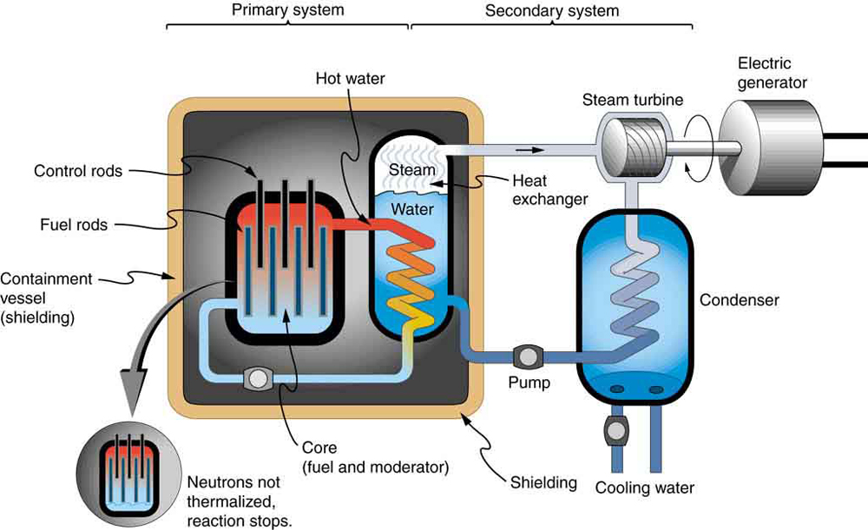

Figure 2: Pressurised water nuclear reactor diagram

The nuclear reactor shown above uses Uranium-238 as a fuel source. The Uranium undergoes fission according to the following equation:

1. How many neutrons are released as a product of this fission reaction? (1 mark)

(1)

1. Calculate the energy (in electron volts) released by the fission reaction shown in part a). (4 marks)

|  |  |
| --- | --- |
| **Element** | **Mass (u)** |
| Uranium-238 | 238.050784 |
| Strontium-38 | 95.921750 |
| Xenon-140 | 139.92164 |
| Neutron | 1.008665 |

(1)

(1)

(1)

(1)

1. Name and describe two safety features used in nuclear reactors. (4 marks)

Any TWO of the following:

[1 mark – naming features, 1 mark – describing how it works]

* Moderator
  + slows neutrons down so they can undergo fission. If it boils away there are less slow neutrons, so less fission reactions
* Control rods
  + absorb extra neutrons so the chain reaction doesn’t go out of control, can also prevent over heating
* Shielding
  + Absorbs radiation and reduces the intensity of the radiation escaping the reactor, the thicker shield the less radiation gets through
* Cooling systems
  + removes excess heat from the reactor, stops the nuclear fuel from reaching its melting point
* Radiation monitors
  + measure how much radiation staff have been exposed to in order to keep their level of exposure below accepted standards

1. A neutron which induces a U-235 fission is first absorbed by the atom, which becomes the very unstable isotope, U-236. Explain why it is easier for a neutron to enter the U-235 nucleus compared to an alpha particle or a proton. (3 marks)

*(NOTE: should really be 238 but principle is the same)*

* Alpha particle and proton have a positive charge, whereas neutrons have no charge (1)
* The nucleus is positively charged (1)
* Like charges repel (1)

1. The electrical power output of the nuclear reactor facility is 901 MW. Calculate the mass of Uranium-238 fissioned in one year of full-power operation. (5 marks)

(1)

(1)

per atom of

(1)

(1)

(1)

**Question 19 (12 marks)**

9.00 V

3.15 Ω

X

2.00 Ω

R1

R3

R2

R4

4.00 Ω

1. Calculate the resistance value of the resistor labelled X. (4 marks)

(1)

(1)

(1)

(1)

1. Calculate the total amount of power used by the circuit when the switch is open. (2 marks)

and

So

(1)

(1)

1. Calculate the total resistance of the circuit when the switch is closed. (3 marks)

(1)

(1)

(1)

1. Calculate the power dissipated by the 2-ohm resistor (only) when the switch is closed. (3 marks)

(0.5)

V1 = Itot R1

V1 = 1.61 x 3.15 = 5.0715 (0.5)

Vp = 9 – 5.0715 = 3.9285 V (0.5)

I2/3 = V/R = 3.9285/(2+4.22) = 0.6316 A (0.5)

P = I2R = 0.631622 x 2 (0.5)

= 0.798 W (0.5)

**Question 21 (13 marks)**

Nuclear fusion takes place inside stars to produce large amounts of energy. Our Sun undergoes a series of steps called the proton-proton cycle. This process releases a tremendous amount of energy.

|  |  |
| --- | --- |
| **Element** | **Mass (kg)** |
| Helium-4 | 6.6443 x 10-27 |
| Hydrogen | 1.6732 x 10-27 |
| Helium-3 | 5.0066 x 10-27 |

1. Write the nuclear equation for the middle step of the proton-proton cycle, where a deuterium atom (Hydrogen-2) and a Hydrogen atom fuse to form a Helium-3 atom and gamma radiation. (1 mark)

(or )

1. The final step of the proton-proton cycle is:

Calculate how much energy (in Joules) is released by this reaction. (4 marks)

(1)

(1)

(1)

(1)

**OR**

(1)

(1)

(1)

(1)

1. If the power output from the Sun is , calculate how many kilograms of Helium-3 is used up by the Sun each second. (4 marks)

(1)

(1)

per reaction

(1)

(1)

1. Why does the nuclear fusion process release more energy per nucleon than nuclear fission? (2 marks)

* Nuclear fusion reactions have a bigger mass defect than fission reactions. (1)
* Greater mass defect means more energy is released. (1)

1. One of the requirements for fusion to occur is extremely high temperatures in the order of . Describe why fusion only occurs under these circumstances. (2 marks)

* At very high temperatures atoms are moving extremely fast. (1)
* Can overcome the electrostatic repulsion and get close enough for the strong nuclear force to bind them together. (1)

**END OF SECTION TWO**

**Section Three: Comprehension 8% (12 marks)**

This section has one question. Answer in the space provided. Suggested working time: 15 minutes.

**Question 21 (12 marks)**

**Staying warm in the Arctic**

Inuit people are a collection of indigenous people who live in the Arctic regions of Greenland, Canada and Alaska. In the Arctic the temperature in winter ranges from -35 °C to 0 °C, but it can drop as low as -50 °C. During the summer temperatures range from -10°C up to 10°C.

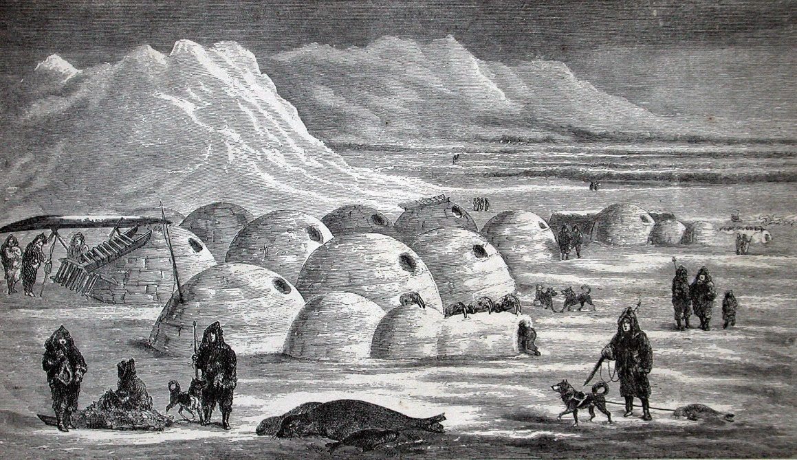

**Figure 4:** Illustration of an Inuit village

On winter hunting trips the Inuit people used to live in temporary shelters called igloos. Igloos are made from compressed snow, which is chopped into large blocks which are then stacked in a dome shape. Compressed snow is used as it contains many small air pockets inside making it a good insulator.

Inside the igloo the floor is uneven with a raised section for sleeping on (see Figure 5). The entrance area acts as a ‘cold trap’ whereas the sleeping area holds any heat generated by stoves, lamps or body heat. Inside the igloo, temperatures can range from −7 °C to 16 °C when warmed by body heat alone. Igloos also have a small ventilation hole to allow smoke from lamps to escape.

Ventilation hole

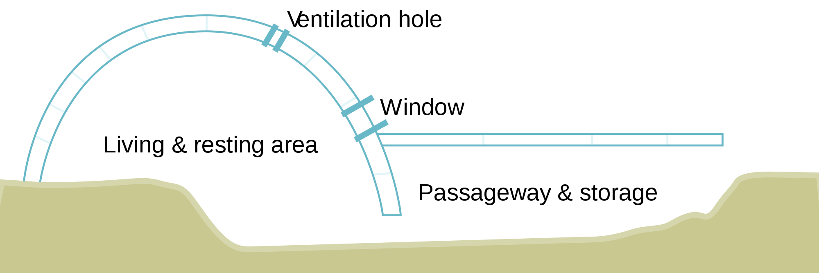

**Figure 5:** Diagram showing the inside of an igloo

1. Explain why the raised sleeping area would ‘hold any heat’ and be warmer than sleeping on the lower level. (3 marks)

* Warm air is less dense than cold air (1)
* Because the warm air is less dense it will rise to the top of the igloo (1)
* This means the raised sleeping area will be warmer than the floor lower down (1)

1. Explain why compressed snow is a better insulator than a solid ice block. (3 marks)

* Compressed snow has small pockets of air – air is a good insulator (1)
* Air is a gas, molecules are further apart than in a solid (1)
* So it takes longer for heat to conduct through air than solid ice (1)

1. Explain why the igloo doesn’t completely melt even when the air temperature inside the igloo is 16 °C. (2 marks)

* Snow/ice has large latent heat of fusion (1)
* The warm air inside the igloo does not have enough energy to melt all of the snow (1)

1. Calculate the amount of energy needed to melt an entire igloo which is at -10 °C. The igloo is made of 150 blocks, each with a volume of 0.05 m3. Compressed snow has a density of . (4 marks)

(1)

(1)

(1)

(1)

**END OF SECTION THREE**